**TRAVEL TO SICILY WITH THE UMBC ANCIENT STUDIES DEPARTMENT, MARCH 13-22, 2026**

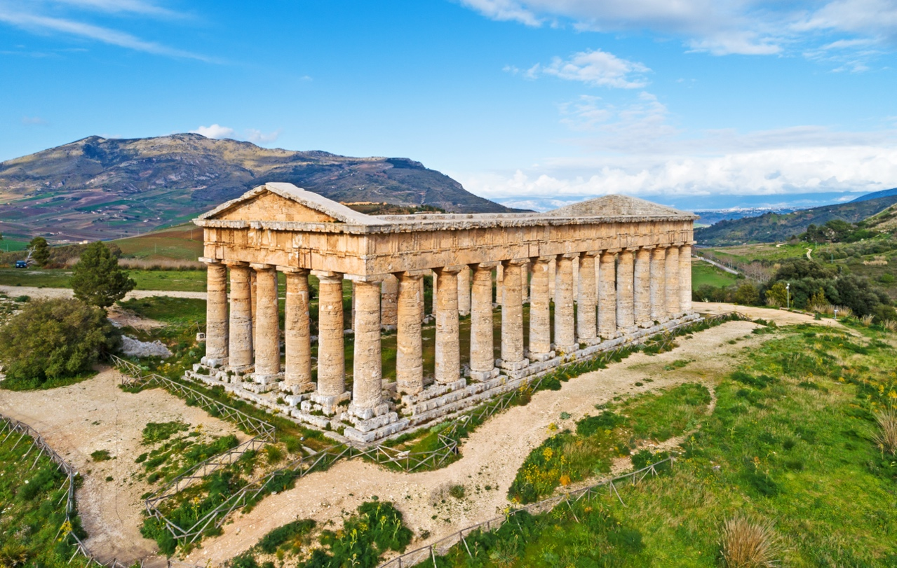

**The Unfinished Doric Temple, Segesta, Sicily**

The UMBC Ancient Studies Department will conduct its annual study tour on the island of Sicily, March 13-22, 2026. The cost of $3,750 covers all air, water, and land transportation, twin-share accommodation for eight nights in three- and four-star hotels, eight buffet breakfasts, two dinners, two lunches, and entrance to all archaeological sites and museums on the itinerary. Single rooms are available at an additional cost of $440. Ancient Studies majors and minors, UMBC students, faculty, staff, alumni, and their friends and family are invited to join us.

You can download a registration form for the trip [here](https://ancientstudies.umbc.edu/wp-content/uploads/sites/99/2025/07/00-Study-Tour-Registration-Form-Sicily-2026.docx) and return it to Lydia DeRidder ([lderidde@umbc.edu](mailto:lderidde@umbc.edu)) by ***Oct.13*, *2025*.** A deposit of $750 is due at this time**.** Ancient Studies majors and minors can download applications for subsidies [here](https://ancientstudies.umbc.edu/wp-content/uploads/sites/99/2025/07/00-Subsidy-Application-SICILY-2026.docx). Please return completed subsidy applications to Dr. David Rosenbloom ([dsrose@umbc.edu](mailto:dsrose@umbc.edu)) by ***Oct. 13*, *2025*.**

Our tour of Sicily begins with a one-night stay in Rome (and a visit to the Colosseum, if we arrive early enough). The next morning we fly to Palermo, Sicily for a one-night stay. We explore the rich cultural heritages of Carthage, Rome, and the Normans, traveling to Marsala (ancient Lilybaeum, Carthaginian/Roman) on the western edge of Sicily for a two-night stay, stopping on the way at the majestic Monreale Cathedral (Norman), Segesta Archaeological Park, Trapani, and Erice (ancient Eryx, Elymian, Carthaginian, Greek, Roman). The following morning we travel to the Carthaginian island stronghold of Mosia (ancient Motya) and return to visit the Regional Museum of Lilybaeum and Marsala Archaeological Park after lunch. From Marsala we journey to the Greek colony of Selinunte (ancient Selinous) to explore the Archaeological Park and Antiquarium before spending the night in the stunning coastal town of Sciacca, renowned for its thermal baths. The following day we travel to the Greek colony of Agrigento (ancient Acragas) to view the celebrated Valley of the Temples. We then proceed to the extraordinary fourth-century CE Villa Romana del Casale en route to Syracuse (Greek colony) for a two-night stay. After taking in the splendors of the Neapolis Archaeological Park, we spend the afternoon on the island of Ortygia (Temple of Apollo, Duomo). The following morning we return to Rome and from there to Dulles International Airport, where a coach will take us back to UMBC.